**MCDONALD’S MARKET SEGMENTATION**

Kartik Sharma

6/04/2024

# INTRODUCTION

McDonald's Corporation is a global fast-food restaurant chain that is renowned for its hamburgers, French fries, and various other fast-food items. Founded in 1940 by Richard and Maurice McDonald, it has grown to become one of the world's largest and most recognizable fast-food brands, serving millions of customers daily in over 100 countries.

Presence:

McDonald's has an extensive global presence, with thousands of restaurants located in urban places, suburbs, and even remote areas worldwide. Its widespread reach extends across continents, making it a ubiquitous presence in the fast-food industry.

Core Business:

The core business of McDonald's revolves around offering quick-service meals that are affordable, convenient, and consistent in quality. Apart from its classic offerings like the Big Mac and Chicken McNuggets, McDonald's also adapts its menu to cater to local tastes and preferences in different regions, showcasing its versatility and adaptability.

Market Segmentation:

Market segmentation is a fundamental concept in marketing that involves dividing a heterogeneous market into smaller, more homogeneous segments based on certain characteristics such as demographics, psychographics, behaviour, or geographic location. By identifying and understanding the distinct needs, preferences, and behaviours of various customer segments, companies like McDonald's can tailor their products, services, and marketing strategies to effectively target and serve each segment.

## DECIDING (NOT) TO SEGMENT

* 1. IMPLICATIONS OF COMMITTING TO MARKET SEGMENTATION

Market segmentation is not merely a fleeting strategy but rather a long-term commitment that requires dedication, resources, and organizational alignment. McDonald and Dunbar (1995) aptly liken market segmentation to a marriage, emphasizing the need for sustained effort and investment from the organization. This commitment entails a willingness to make substantial changes and investments, as Cahill (2006) highlights.

**Investment and Costs:** Implementing a market segmentation strategy involves various costs, including market research, surveys, focus groups, product development, packaging design, and tailored communication messages. These expenses underscore the financial commitment required to effectively segment a market. The truism of segmentation strategy lies in ensuring that the benefits derived from using the segmentation scheme outweigh the costs associated with its development and implementation.

**Organizational Changes:** Embracing market segmentation often necessitates significant organizational changes. This may include the development of new products tailored to specific segments, modifications to existing products to meet segment needs, adjustments in pricing strategies, and shifts in distribution channels. Moreover, communication strategies must be tailored to resonate with each identified segment, further emphasizing the need for adaptability and agility within the organization.

**Strategic Decision Making:** Given the profound implications of committing to market segmentation, the decision to pursue this strategy must be made at the highest executive level within the organization. It requires a systematic approach to evaluating market segments, allocating resources, and aligning organizational objectives with segment-specific strategies. Continuous communication and reinforcement of the segmentation strategy across all levels and units of the organization are essential to ensure alignment and sustained commitment.

**Conclusion:** Market segmentation represents a strategic imperative for organizations seeking to effectively target and serve diverse customer segments. However, its successful implementation requires more than just a superficial commitment. It demands a comprehensive, long-term organizational strategy accompanied by substantial investments, organizational changes, and strategic decision-making processes.

* 1. IMPLEMENTATION BARRIERS

1. Lack of Leadership and Commitment

Lack of proactive involvement and commitment from senior management can hamper market segmentation's performance. Without strong leadership backing the programme, implementation attempts may falter.

1. Resource Allocation

Senior management's insufficient allocation of resources for market segmentation analysis and long-term strategy implementation can hinder progress. Without proper assistance, teams may struggle to perform detailed analysis and carry out effective initiatives.

1. Resistance to change by the Organization

Lack of openness to new ideas can hinder market segmentation implementation. Without a culture that values innovation and adaptation, efforts to segment markets and adjust strategy may be met with opposition.

1. Lack of Market Orientation and Communication

Organizations without a market or consumer orientation, as well as poor communication and information-sharing between departments, may struggle to conduct efficient market segmentation. Segmentation tactics may not resonate with target audiences unless they are based on a shared knowledge of customer wants and insights.

1. Lack of Training and Expertise

Barriers to successful market segmentation implementation include a lack of training and expertise among senior management and teams. Organisations without sufficient training and competence may fail to establish and implement successful segmentation strategies.

1. Lack of Qualified Marketing Resources

Implementing market segmentation might be challenging without a structured marketing function or qualified professionals within the organisation. Without the essential knowledge, organisations may lack the strategic direction required to handle difficult segmentation initiatives.

1. Financial Restrictions

Objective restrictions such as limited financial resources or structural constraints within the organization can impede market segmentation efforts. Inability to invest in necessary resources or make structural changes required for segmentation may hinder implementation success.

* 1. APPROACH TO OVERCOME IMPLEMENTATION BARRIERS

**Identifying and Addressing Barriers:**

Recognizing and understanding the barriers to market segmentation implementation is essential for organizations to devise effective strategies to overcome them. At a practical level, Doyle and Saunders (1985) advocate for making market segmentation analysis comprehensible to management by utilizing graphical visualizations to present results in an accessible manner.

**Proactive Strategy:**

Many barriers to market segmentation can be anticipated and mitigated proactively during the initial stages of a segmentation study. Organizations should adopt a proactive approach to identify and remove barriers to enhance the chances of successful implementation. However, if certain barriers cannot be adequately addressed, organizations should consider the option of reassessing the pursuit of market segmentation as a viable strategy.

**Action Plan:**

McDonald and Dunbar (1995) provide useful recommendations for conducting market segmentation study. They emphasise the significance of retaining a strong sense of purpose and determination, as well as patience and a willingness to face and overcome the inevitable problems that will arise during implementation.

* 1. STRATEGY BY MCDONALD’S

*"Above all, a resolute sense of purpose and dedication is required, tempered by patience and a willingness to appreciate the inevitable problems which will be encountered in implementing the conclusions."*

**Simplified Communication:**

McDonald's employs a strategy of simplifying market segmentation analysis and results for senior management's comprehension. Utilizing graphical visualizations and straightforward presentations, the company ensures that management can easily understand and interpret the insights derived from segmentation studies.

**Proactive Barrier Identification:**

McDonald's adopts a proactive approach to identify and address barriers to market segmentation implementation from the outset of a segmentation study. By anticipating potential challenges and devising strategies to overcome them, McDonald's enhances its ability to execute successful segmentation strategies.

**Dedication and Patience:**

In line with McDonald and Dunbar's recommendations, McDonald's maintains a steadfast commitment to market segmentation, tempered by patience and a willingness to navigate challenges. This dedication allows the company to persevere through obstacles and implement segmentation strategies effectively.

In summary, McDonald's approach to overcoming implementation barriers revolves around simplified communication, proactive barrier identification, and a resolute commitment to dedication and patience in executing segmentation strategies.

* 1. CHECKLIST

This checklist contains a list of tasks as well as questions which can give clarity whether market segmentation is needed/good for a company or not.

For example: If an organization (example McDonald’s) is market oriented then it can proceed to next question in the list.

**Questions to Assess Organizational Readiness:**

* Is the organization's culture market-oriented?
* Is the organization genuinely willing to change?
* Does the organization take a long-term perspective?
* Is the organization open to new ideas?
* Is communication across organizational units good?
* Is the organization in a position to make significant (structural) changes?
* Does the organization have sufficient financial resources to support a market segmentation strategy?

**Steps to Ensure Effective Implementation:**

* Secure visible commitment to market segmentation from senior management.
* Secure active involvement of senior management in the market segmentation analysis.
* Secure required financial commitment from senior management.
* Ensure that the market segmentation concept is fully understood. If not, conduct training until understood.
* Ensure that the implications of pursuing a market segmentation strategy are fully understood. If not, conduct training until understood.
* Put together a team of 2-3 people to conduct the market segmentation analysis.
* Ensure that a marketing expert, a data expert, and a data analysis expert are on the team.
* Set up an advisory committee representing all affected organizational units.
* Ensure that the objectives of the market segmentation analysis are clear.
* Develop a structured process to follow during market segmentation analysis.
* Assign responsibilities to segmentation team members using the structured process.
* Ensure that there is enough time allocated to perform market segmentation.

## SPECIFYING THE IDEAL TARGET SEGMENT

2.1 SEGMENT EVALUATION CRITERIA

This layer of market segmentation relies mainly on user input. For a market segmentation analysis to produce results that are useful to an organization, user input cannot be limited to either a briefing at the start of the process, or the development of marketing mix at the end.

McDonald's, employs a comprehensive set of evaluation criteria to assess and select market segments. These criteria encompass various factors across different dimensions:

**Segment Factors:** Size, growth rate per year, sensitivity to price and service features, external factors such as cyclicality, seasonality, and bargaining power of upstream suppliers.

**Competition:** Types of competition, degree of concentration, changes in type and mix, entries and exits, changes in share, substitution by new technology, degrees and type of integration.

**Financial and Economic Factors:** Contribution margins, capacity utilization, leveraging factors such as experience and economies of scale, barriers to entry or exit.

**Technological Factors:** Maturity and volatility, complexity, differentiation, patents and copyrights, manufacturing processes.

**Socio-political Factors:** Social attitudes and trends, laws and government agency regulations, influence with pressure groups and government representatives, human factors such as unionization and community acceptance.

These criteria help McDonald's evaluate market segments comprehensively, ensuring alignment with its strategic goals and operational capabilities. Hence, Segment evaluation criteria are essential for organizations to effectively target and prioritize market segments. By considering diverse factors, organizations can identify segments that offer the greatest potential for profitability and growth, aligning with their strategic objectives and operational capabilities.

2.2 KNOCK OUT CRITERIA

Knock-out criteria are essential characteristics that a market segment must possess to be considered for targeting. These criteria serve as dealbreakers, ruling out segments that would not be a good fit for the business.

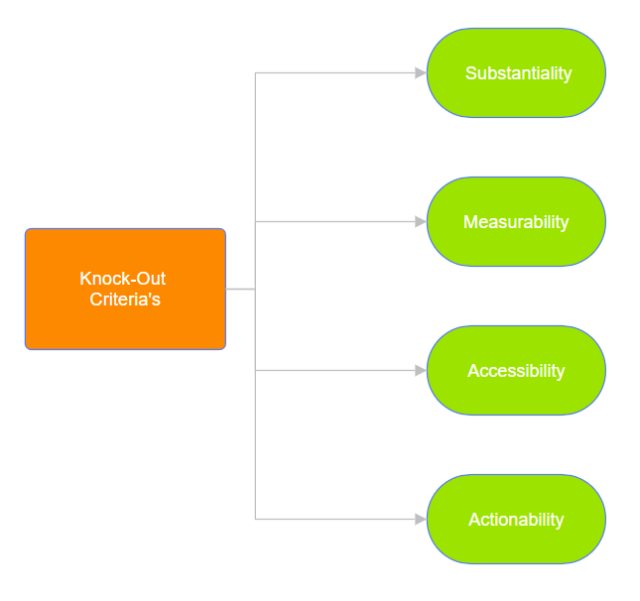

Here are some common knock-out criteria:

* **Substantiality:** Is the segment large enough to be profitable? A segment must have sufficient size and purchasing power to warrant investment in marketing efforts and resources.
* **Measurability:** Can the segment be easily identified and its size measured? It's crucial for a segment to be quantifiable and measurable to assess its potential and track performance accurately.
* **Accessibility:** Can the segment be reached through marketing and distribution channels? A segment should be accessible through existing or feasible marketing and distribution channels to effectively target and serve its needs.
* **Actionability:** Can the company develop and deliver marketing programs tailored to the segment? A segment should be actionable, meaning the company can develop and implement marketing strategies and programs that resonate with the segment's needs and preferences.

These knock-out criteria help organizations filter and prioritize market segments, ensuring that resources are allocated to segments with the greatest potential for profitability and growth.

2.3 ATTRACTIVENESS CRITERIA

Attractiveness criteria are employed after applying the knock-out criteria to evaluate the remaining segments and determine which ones are most appealing for the business. These criteria assist in prioritizing segments based on their potential for profitability and growth.

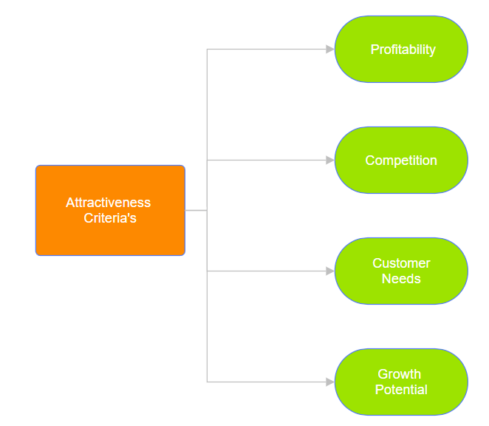

Here are some examples of attractiveness criteria:

**Growth Potential:** Is the segment expected to grow in size or purchasing power? Segments with significant growth potential offer opportunities for expanding market share and increasing revenue over time.

**Profitability:** Is the segment willing to pay a premium for the product or service? Segments that demonstrate a willingness to pay higher prices for value-added products or services are more attractive from a profitability standpoint.

**Competition:** How intense is the competition in the segment? Segments with low competition or where the company has a competitive advantage are more attractive as they offer opportunities for capturing market share and maintaining profitability.

**Customer Needs:** How well does the product or service align with the needs of the segment? Segments with needs that closely match the company's offerings are more attractive as they are likely to result in higher customer satisfaction and loyalty.

By considering these attractiveness criteria, organizations can prioritize segments that offer the greatest potential for long-term profitability and growth, aligning with their strategic objectives and capabilities.

IMPLEMENTED A STRUCTURED PROCESS (MCDONALD’S PERSPECTIVE)

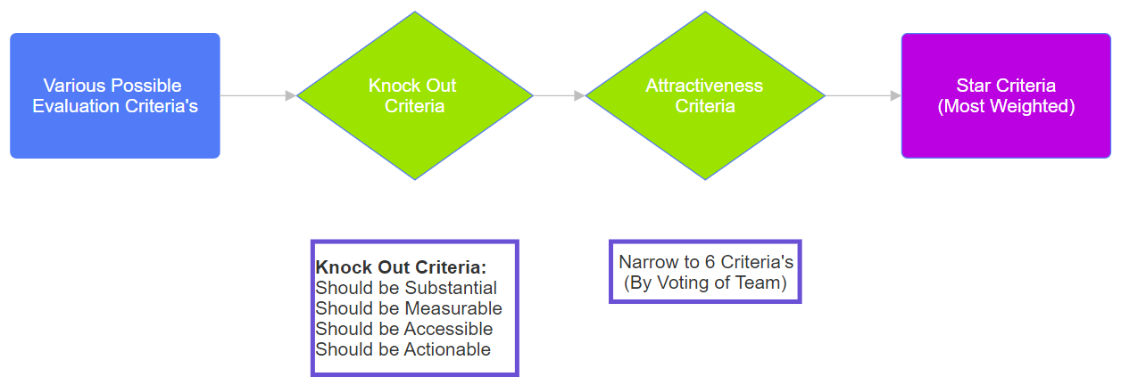

The above figure shows how Knock Out criteria works and only sends the evaluation criteria which meet some of its conditions. Then conditions of Attractiveness Criteria helps the segmentation team to narrow down from a number of criteria’s to a number to six only. Finally, Star Criteria is found.

Market segmentation at McDonald's operates through a meticulous two-step filtering process: Knock-Out criteria and Attractiveness Criteria. These criteria synergize to pinpoint the most promising target markets for our business.

At McDonald's, the determination of segment attractiveness and organizational competitiveness values is entrusted to our segmentation team. Initially, a broad array of evaluation criteria is considered within our knock-out criteria framework. These criteria are rigorously assessed to identify segments that meet essential characteristics for targeting.

Subsequently, a refined set of six criteria is selected to form our attractiveness criteria. These criteria represent the most influential factors contributing to segment desirability and organizational competitiveness. To quantify their importance, each of the six criteria is assigned a score out of 100 (distributed according to team members own choice), reflecting its relative weight in our market segmentation analysis. For example, criteria may be weighted as 30, 20, 10, 10, 15, and 15, summing up to 100 and here we can see the criteria/factor having maximum weight 30 is most crucial out of the others. This weighting process enables us to prioritize criteria based on their significance to McDonald's strategic objectives and operational capabilities.

Drawing from a core team of two to three individuals primarily responsible for market segmentation analysis, McDonald's initiates the process by proposing an initial solution. This proposal is then presented to our advisory committee, comprising representatives from all organizational units, for discussion and potential modification.

Involving representatives from diverse organizational units holds paramount importance for McDonald's. Firstly, each unit brings a distinct perspective on our business, enriching discussions with varied viewpoints. Secondly, since the segmentation strategy impacts every unit within our organization, all units become integral stakeholders in our market segmentation analysis.

Upon conclusion of this step, our market segmentation team meticulously compiles a list of approximately six segment attractiveness criteria. Each criterion is weighted to reflect its importance to McDonald's relative to others. The typical approach to weighting, as outlined by McDonald and Dunbar in 2012, involves soliciting input from all team members to distribute 100 points across the segmentation criteria. These allocations undergo negotiation until consensus is achieved, ensuring a balanced and strategic approach.

2.4 CHECKLIST

1. Convene Segmentation Team Meeting:

Schedule and organize a meeting with the segmentation team.

1. Define Knock-Out Criteria:

Ensure these criteria are agreed upon for automatic elimination of non-compliant segments.

1. Present Knock-Out Criteria to Advisory Committee:

Present the knock-out criteria to the committee for discussion and potential adjustment.

Knock Out Criteria’s are –

* Substantiality
* Measurability
* Accessibility
* Actionability

1. Study Market Segment Attractiveness Criteria:

Individually study available criteria for assessing market segment attractiveness.

1. Discuss and Select Attractiveness Criteria:

* Discuss attractiveness criteria with segmentation team members.
* Agree on a subset of no more than six criteria.

1. Distribute Points Across Attractiveness Criteria:

* Individually distribute 100 points across the agreed-upon attractiveness criteria.
* Distribute points to reflect the relative importance of each criterion.

1. Discuss and Agree on Weightings:

* Discuss weightings with other segmentation team members.
* Agree on weightings that reflect the importance of each attractiveness criterion.

1. Present Criteria and Weightings to Advisory Committee:

Present the selected segment attractiveness criteria and proposed weightings to the advisory committee for discussion and potential adjustment.

## 3 COLLECTING DATA

Empirical data serves as the cornerstone for both common-sense and data-driven market segmentation. In the context of McDonald's fast-food chain, data collection is indispensable for crafting effective marketing strategies and refining market segmentation approaches.

Market segmentation allows McDonald's to divide its customer base into distinct groups with shared characteristics, behaviour’s, and preferences. By collecting data on demographic factors such as age, gender, income level, and location, McDonald's gains insights into the diverse needs and preferences of its customers. This data informs targeted marketing campaigns tailored to specific customer segments, enhancing the relevance and effectiveness of promotional efforts.

Moreover, data on consumer behaviour and purchasing patterns enables McDonald's to understand the preferences and trends driving customer choices. By analysing behavioural data, such as past purchase history, frequency of visits, and menu preferences, McDonald's can identify opportunities for product innovation, menu optimization, and customer engagement initiatives. Data-driven insights empower McDonald's to anticipate evolving consumer preferences, adapt its offerings accordingly, and maintain a competitive edge in the fast-food industry.

In essence, data collection underpins McDonald's market segmentation and marketing strategies, enabling the company to deliver personalized experiences, drive customer engagement, and sustain long-term success in an ever-evolving market landscape.

3.1 SEGMENTATION VARIABLE AND CRITERIA

In strategizing market segmentation, McDonald's employs a pragmatic approach, aligning segmentation variables and criteria with its organizational goals and product offerings. While considering segmentation variables, McDonald's emphasizes the importance of empirical data to split its customer base into meaningful segments.

Traditionally, McDonald's has utilized common-sense segmentation, often focusing on single characteristics like demographics (e.g., age or gender) to create segments such as "families" or "young adults." However, in today's data-driven landscape, McDonald's recognizes the value of employing multiple segmentation variables. This approach allows for a more nuanced understanding of consumer behaviour and preferences, enabling McDonald's to tailor its offerings and marketing strategies more effectively.

Empirical data serves as the foundation of McDonald's market segmentation efforts, drawn from various sources such as surveys, loyalty programs, and observational studies. This data provides insights into consumer behaviour, purchasing patterns, and preferences, essential for crafting targeted marketing messages and offerings.

Before extracting segments, McDonald's carefully selects segmentation criteria, considering factors like geographic, sociodemographic, psychographic, and behavioural variables. Additionally, McDonald's evaluates criteria such as profitability, bargaining power, and consumer interaction effects to ensure alignment with its business objectives and product characteristics.

Despite the allure of more sophisticated segmentation approaches, McDonald's remains pragmatic in its strategy. The company prioritizes the segmentation approach that maximizes effectiveness at the least cost. Whether it's demographic, geographic, or psychographic segmentation, McDonald's chooses the approach that best serves its product offerings and resonates with its target market.

In essence, McDonald's adopts a data-informed, pragmatic approach to segmentation variables and criteria, leveraging empirical data and aligning with organizational objectives to drive customer engagement and satisfaction.

3.2 SEGMENTATION CRITERIA

McDonald's carefully considers various criteria to effectively target its diverse customer base. Let's explore how McDonald's employs geographic, socio-demographic, psychographic, and behavioural segmentation criteria in its approach:



**Geographic Segmentation**

McDonald's utilizes geographic segmentation to understand regional preferences and tailor its offerings accordingly. By considering factors such as local tastes, cultural preferences, and economic conditions, McDonald's can adapt its menu and promotional activities to resonate with customers in different geographical areas. While geographic segmentation simplifies assigning consumers to specific regions, McDonald's recognizes the need to supplement this approach with additional criteria to capture nuanced consumer preferences comprehensively.

**Socio-Demographic Segmentation**

Socio-demographic segmentation, encompassing age, gender, income, and education, plays a significant role in McDonald's marketing strategies. Understanding the socio-demographic makeup of its customer base allows McDonald's to customize its menu offerings, pricing strategies, and advertising campaigns to appeal to specific demographic segments. By leveraging socio-demographic criteria, McDonald's can create targeted promotions for families, young adults, or seniors, maximizing engagement and satisfaction among different consumer groups.

**Psychographic Segmentation**

McDonald's delves into psychographic segmentation to gain insights into consumers' beliefs, interests, and preferences. By understanding the psychographic profiles of its customers, McDonald's can craft marketing messages and menu innovations that resonate with their underlying motivations and aspirations. While psychographic segmentation offers deeper insights into consumer behaviour, McDonald's acknowledges the complexity of determining segment memberships and invests in reliable empirical measures to capture psychographic dimensions effectively.

**Behavioural Segmentation**

Behavioural segmentation forms the backbone of McDonald's customer-centric approach. By analysing consumers' past behaviour’s, purchase patterns, and interactions with the brand, McDonald's can identify key trends and preferences driving customer choices. While behavioural data may not always be readily available, especially for potential customers who haven't previously patronized McDonald's, the company leverages innovative methods to gather insights and tailor its offerings to meet evolving consumer needs effectively.

In summary, McDonald's strategically integrates geographic, socio-demographic, psychographic, and behavioural segmentation criteria to understand its customer base comprehensively. By leveraging these criteria, McDonald's can deliver personalized experiences, drive customer engagement, and maintain its position as a leader in the fast-food industry.

3.3 DATA SELECTION AND GATHERING

* **SURVEY DATA COLLECTION**

McDonald's has undergone a significant evolution in its approach to data selection and gathering for market segmentation. Initially, like many organizations, McDonald's relied heavily on survey data for its market segmentation efforts. Survey data provided valuable insights into customer preferences and behaviour’s, serving as the foundation for segmentation strategies.

However, McDonald's recognized the limitations of survey data, particularly its susceptibility to biases and its inability to capture real-time consumer behaviour accurately. As technology advanced and new data sources became available, McDonald's shifted its approach to incorporate a more diverse range of data sources, including transactional data, social media analytics, and customer feedback.

This shift allowed McDonald's to gather more comprehensive and dynamic data, enabling a deeper understanding of customer preferences and behaviour’s. By leveraging advanced analytics and machine learning algorithms, McDonald's could analyse vast amounts of data in real time, uncovering actionable insights to inform its segmentation strategies.

Today, McDonald's employs a multifaceted approach to data selection and gathering for market segmentation. While survey data still plays a role, it is complemented by a diverse range of data sources that provide a more holistic view of customer behaviour. McDonald's continues to refine its segmentation strategies to better meet the evolving needs and preferences of its customers.

Also, if the sample size is sufficient, it is very easy to determine the number and nature of segments. The sample size should be at least 2p (better five times 2p), where p is the number of segmentation variables in the data set.

In summary, McDonald's journey from relying solely on survey data to incorporating a diverse range of data sources reflects its commitment to innovation and adaptation in the pursuit of effective market segmentation strategies.

* **DATA FROM INTERNAL SOURCES**

McDonald's recognizes the value of leveraging internal data for market segmentation analysis, as it provides access to substantial amounts of valuable information. Examples of such internal data include scanner data from McDonald's locations, loyalty program booking data, and online purchase data.

**Accessibility and Automatic Generation**

One of the key advantages of using internal data is its accessibility and automatic generation. Internal data, such as scanner data from McDonald's outlets and booking data from loyalty programs, are often automatically generated. Additionally, if McDonald's has systems in place to store data efficiently, accessing this information requires minimal effort.

**Potential Bias and Limitations**

However, McDonald's acknowledges the potential limitations of relying solely on internal data for market segmentation analysis. One significant concern is the risk of systematic bias, particularly in over-representing existing customers. Internal data primarily capture the behaviour’s and preferences of current customers, potentially overlooking valuable insights into prospective customers with different consumption patterns.

In addressing these limitations, McDonald's adopts a balanced approach, combining internal data with external sources to gain a more comprehensive understanding of market segments. By supplementing internal data with external market research and consumer insights, McDonald's aims to mitigate biases and ensure the effectiveness of its market segmentation strategies.

In summary, while internal data offer valuable insights into customer behaviour, McDonald's recognizes the importance of complementing this information with external sources to develop robust and inclusive market segmentation strategies.

* **DATA FROM EXPERIMENTAL STUDIES**

McDonald's explores experimental data as a source for market segmentation insights, leveraging experiments to understand consumer behaviour in controlled settings. These experiments encompass studies on advertisement response, choice experiments, and conjoint analyses, providing valuable insights into consumer preferences and purchasing decisions. By conducting experiments, McDonald's gains actionable insights into effective marketing strategies and product attributes that resonate with target segments.

While experimental data offer valuable insights, McDonald's acknowledges limitations such as the artificial nature of laboratory experiments and the need to validate findings in real-world settings. McDonald's integrates experimental data with other sources, such as survey and internal data, to develop comprehensive market segmentation strategies. By combining insights from experiments with real-world data, McDonald's enhances its understanding of consumer behaviour and tailors marketing efforts to effectively target different segments.

## 4 PROFILING SEGMENTS

The aim of the profiling step is to gain insight into the market segments resulting from the extraction process. Profiling becomes essential when employing data-driven market segmentation techniques. While the segmentation solution may determine segments based on consumer benefits sought, the specific characteristics of these segments remain unknown until data analysis is conducted. Profiling involves characterizing each market segment individually and comparing them to others, aiming to identify defining characteristics in relation to the segmentation variables. This process enables a deeper understanding of each segment's unique attributes and facilitates targeted marketing strategies tailored to meet their specific needs and preferences.

4.1 APPROACHES TO PROFILING MARKET SEGMENTS

Data-driven segmentation solutions are typically presented to users, such as clients or managers, in one of two ways: either as high-level summaries simplifying segment characteristics to a point where they may be misleadingly trivial, or as large tables providing exact percentages for each segmentation variable within each segment. However, these tabular presentations can be challenging to interpret and may not offer a quick overview of key insights.

In response to this challenge, McDonald's employs visualizations as a crucial approach to profiling market segments. Graphics play a significant role in exploratory statistical analysis, particularly in techniques like cluster analysis, as they offer insights into the complex relationships between variables. The use of visualization techniques enhances the interpretability of results from market segmentation analyses, making it easier for stakeholders to understand and derive actionable insights from the segmented data.

4.2 IDENTIFYING DEFINING CHARACTERISTICS OF MARKET SEGMENTS

After employing visualizations and exploring the complex relationships between variables, the next step in profiling market segments involves identifying their defining characteristics. This process aims to pinpoint the key attributes that differentiate one segment from another and provide valuable insights for targeted marketing strategies.

McDonald's utilizes advanced data analysis techniques to identify the defining characteristics of its market segments. By analysing customer preferences, behaviour’s, and demographics, McDonald's can uncover patterns and trends that distinguish one segment from another. Through thorough analysis and interpretation of data, McDonald's can identify the unique traits and preferences of each segment, allowing for tailored marketing strategies and personalized experiences.

In its segmentation approach, McDonald's has selected 15 characteristics to represent various aspects of consumer preferences and behaviour’s. These characteristics encompass a range of factors, including taste preferences, convenience, pricing perceptions, health considerations, and demographic factors such as age and gender. By understanding these defining characteristics, McDonald's can effectively target each segment with customized marketing campaigns and product offerings tailored to their specific needs and preferences.

4.3 CHARACTERISTICS USED FOR MARKET SEGMENTATION

McDonald's employs a comprehensive set of 15 characteristics to effectively cluster customers into distinct segments. These characteristics encompass various aspects of consumer preferences and behaviour’s, providing valuable insights for targeted marketing strategies. Here are the 15 characteristics utilized by McDonald's for segment creation:

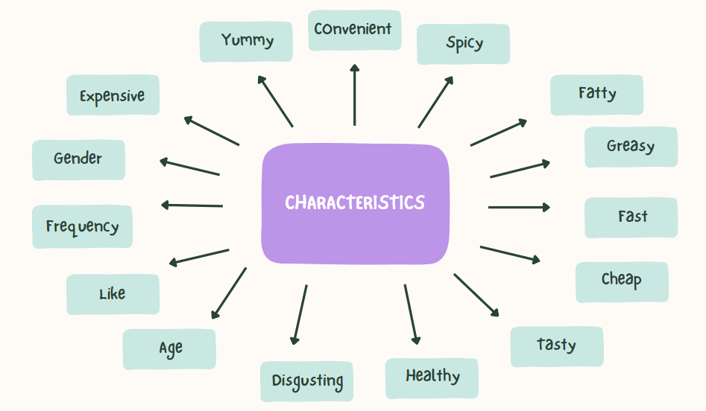

* **Yummy:** Assessing the overall taste and appeal of McDonald's menu items.
* **Convenient:** Evaluating the convenience and accessibility of McDonald's locations and services.
* **Spicy:** Identifying preferences for spicy flavours among customers.
* **Fattening:** Considering perceptions of the nutritional content and calorie density of McDonald's offerings.
* **Greasy:** Gauging attitudes towards the greasiness or oiliness of McDonald's food.
* **Fast:** Examining preferences for quick service and efficient dining experiences.
* **Cheap:** Assessing perceptions of affordability and value for money at McDonald's.
* **Tasty:** Evaluating overall taste satisfaction and enjoyment of McDonald's products.
* **Expensive:** Understanding perceptions of pricing and affordability compared to competitors.
* **Healthy:** Considering preferences for healthier options and nutritional content.
* **Disgusting:** Assessing negative perceptions or aversions towards certain menu items.
* **Like:** Capturing general preferences and overall satisfaction with McDonald's offerings.
* **Age:** Segmenting customers based on age demographics.
* **Visit Frequency:** Analysing the frequency of customer visits to McDonald's outlets.
* **Gender:** Considering gender demographics and preferences in segment creation.

By analysing these characteristics, McDonald's can segment their customer base into distinct groups with shared preferences. This empowers them to develop tailored marketing strategies. Imagine sending spicy burger coupons to customers who indicated a preference for "spicy," or promoting healthy Happy Meal options to health-conscious families. Additionally, understanding customer segments allows McDonald's to personalize the customer experience. In-store displays or digital signage can showcase relevant menu items based on a customer's perceived preferences.

4.4 UNDERSTANDING THE DEFINING CHARACTERISTICS

A fundamental method for comprehending the defining characteristics of each market segment is to produce a segment profile plot. This visualization tool displays, for all segmentation variables, the unique differences between each market segment and the overall sample. Referred to as a panel plot, the segment profile plot presents each characteristic as a separate panel, with each panel representing one segment. Within each segment, the plot showcases the cluster centres, also known as centroids, which serve as representative points of the segments.

At McDonald's, while the importance of this method is recognized, specific approaches to segmentation and analysis may vary. The company acknowledges the significance of understanding the unique traits and preferences of different market segments. Through advanced data analysis techniques and visualizations, McDonald's continually evaluates various characteristics to gauge their impact on consumer behaviour. Factors such as taste preferences, convenience, pricing perceptions, health considerations, and demographic attributes like age and gender are meticulously examined to inform marketing strategies.

4.5 ASSESSING SEGMENT SEPARATION

Segment separation, crucial for understanding the distinctiveness of market segments, is often visualized through a segment separation plot. This plot illustrates the overlap of segments across all relevant dimensions of the data space. While segment separation plots are straightforward when the number of segmentation variables is limited, they become more intricate as the number of variables increases. Each plot provides a glimpse into one potential projection of the data space, offering insights into the degree of segregation among segments.

At McDonald's, while the importance of segment separation is acknowledged, the specific methodologies employed may vary. The company recognizes the significance of delineating clear boundaries between market segments to tailor marketing strategies effectively. Through comprehensive data analysis and visualization techniques, McDonald's endeavours to assess segment separation to identify distinct consumer groups with unique preferences and behaviour’s. While the exact approach to segment separation visualization within McDonald's operations may not be publicly disclosed, the company likely employs sophisticated analytical tools to evaluate segment distinctiveness and inform strategic decision-making.

4.6 CONCLUSION

McDonald's employs a multifaceted approach to market segmentation, leveraging 15 key characteristics of customers to delineate distinct consumer segments. These characteristics encompass various factors such as taste preferences, dietary considerations, convenience, and demographic attributes like age, visit frequency, and gender. Utilizing these parameters, McDonald's endeavours to understand and cater to the diverse needs and preferences of its customer base.

In our analysis, employing the elbow method on a dataset comprising 1453 rows of customer data and 15 columns of characteristics revealed the break point at 4 so we will divide our customers into 5 groups. This segmentation approach enables McDonald's to gain deeper insights into consumer behaviour and preferences, facilitating the development of targeted marketing strategies tailored to each segment's unique needs. By leveraging data-driven segmentation techniques, McDonald's remains poised to adapt to evolving consumer trends and enhance its competitive edge in the fast-food industry.